Configuring Outlook for NKSESI.COM

1. Add an account in Outlook

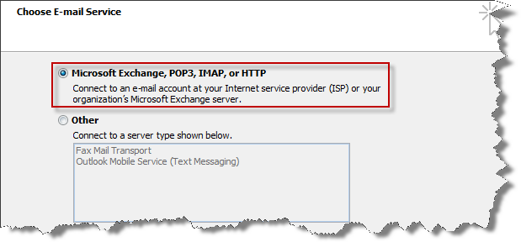

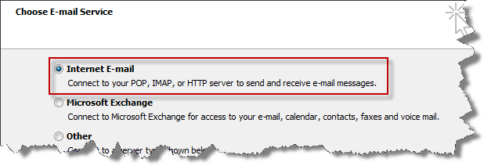

1. Use the Manual Config of Outlook

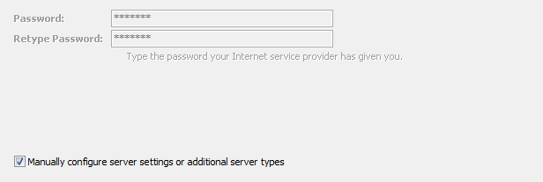

1. Server and Account Setting

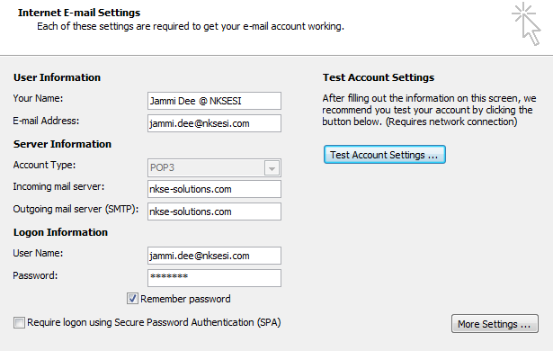

1. Initial Email Accounts

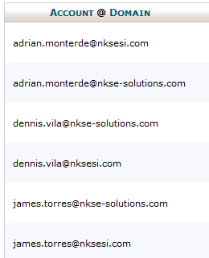

The email is also the login name. All Passwords are temporarily set to username123!

Example: adrian123!, james123!, dennis123!

1. To follow setting your own password personally Guide.